ASSESSMENT FILE
COMPTIA N+
Network Security, Maintenance & Troubleshooting Procedures
Section A — Concept Application
SCENARIO 1 : Nexus Innovations is purchasing new computers for employees who use programming software, web browsers, and video conferencing applications at the same time.
Question: What factors should be considered when selecting the CPU, RAM, and storage to ensure good performance and hardware compatibility?
ANSWER:

Factors to Consider When Selecting CPU, RAM and Storage
For Nexus Innovations, employees need computers that can run programming software, web browsers and video conferencing applications simultaneously. Therefore, the CPU, RAM and storage should be selected carefully to ensure good performance and hardware compatibility.

1. CPU (Central Processing Unit)
- Processor speed: Choose a processor with good clock speed for faster task execution.
- Number of cores: A multi-core processor (at least 6 cores) helps run multiple applications smoothly.
- Generation: Select a modern processor generation for better performance and efficiency.
- Compatibility: Check that the processor is supported by the motherboard socket and chipset.

2. RAM (Random Access Memory)
- Capacity: Minimum 16 GB RAM is recommended for multitasking. 32 GB is better for heavy programming work.
- RAM Type: Choose compatible DDR4 or DDR5 RAM depending on motherboard support.
- Speed: Select RAM speed supported by the motherboard and processor.
- Upgradability: Choose a motherboard with extra RAM slots for future upgrades.

3. Storage
- SSD: Choose an SSD for faster booting and application loading.
- Capacity: At least 512 GB SSD is recommended; 1 TB is better for storing programming tools and files.
- NVMe SSD: Prefer NVMe SSD for faster data transfer compared to traditional HDDs.
- Compatibility: Check motherboard support for SATA or M.2 NVMe storage.

4. Hardware Compatibility
Before purchasing computers, check:
- CPU compatibility with motherboard socket and chipset.
- RAM type, speed and maximum capacity supported by motherboard.
- Storage interface compatibility (SATA or M.2 NVMe).
- Power supply and cooling requirements.
- Availability of upgrade options.

5. Recommended Configuration
Component | Recommendation
CPU | Modern 6-core or 8-core processor
RAM | 16 GB DDR5 (32 GB for heavy workloads)
Storage | 512 GB or 1 TB NVMe SSD
Motherboard | Compatible with CPU, RAM and SSD
Cooling | Proper CPU cooling system

Conclusion
Nexus Innovations should select computers with a modern multi-core CPU, at least 16 GB RAM and a fast SSD. Hardware compatibility and future upgrade options should also be considered. These components will help employees run multiple applications smoothly and improve productivity. 💻

SCENARIO 2: After installing antivirus software on all startup office computers, employees notice that their systems have become slower.
Question: Explain how the antivirus software affects CPU, RAM, and storage performance, leading to system slowdowns.
ANSWER:

How Antivirus Software Affects System Performance
Antivirus software protects computers from viruses, malware and other security threats. However, it uses system resources such as CPU, RAM and storage. This can sometimes make computers slower.

1. Effect on CPU (Central Processing Unit)
- Antivirus continuously monitors running programs and files.
- It uses CPU power to scan files and detect threats.
- Full system scans can increase CPU usage.
- High CPU usage can make other applications run slowly.

2. Effect on RAM (Random Access Memory)
- Antivirus software runs background processes.
- These processes consume RAM.
- Real-time protection and security updates require additional memory.
- Less available RAM can slow down multitasking and application performance.

3. Effect on Storage
- Antivirus scans files stored on HDDs and SSDs.
- It reads and checks many files, increasing disk activity.
- Antivirus updates and quarantine files also use storage space.
- High disk usage can increase application loading time, especially on older HDDs.

4. Ways to Improve Performance
- Schedule antivirus scans during non-working hours.
- Avoid running multiple antivirus programs simultaneously.
- Keep antivirus software updated.
- Close unnecessary background applications.
- Use SSD storage and sufficient RAM.
- Configure antivirus settings carefully without disabling essential protection.

Conclusion
Antivirus software can slow down a computer because it consumes CPU, RAM and storage resources while scanning and protecting the system. Proper configuration, scheduled scans and sufficient hardware resources can reduce performance issues while maintaining security.

SCENARIO 3 :A USB keyboard and printer work properly on one computer but do not work correctly on another computer in the startup office.
Question: Describe the steps you would follow to troubleshoot the problem if it is caused by driver incompatibility or operating system issues.
ANSWER:

Troubleshooting Driver Incompatibility and Operating System Issues
If a USB keyboard and printer work properly on one computer but not on another, the problem may be caused by outdated or incompatible drivers or operating system issues.
The following steps can be used to troubleshoot the problem:

1. Check USB Connections
- Connect the keyboard and printer properly.
- Try different USB ports.
- Restart the computer and reconnect the devices.

2. Check Device Manager
- Open Device Manager in Windows.
- Check for yellow warning signs or unknown devices.
- Identify devices with driver-related errors.

3. Update or Reinstall Drivers
- Right-click the problematic device.
- Select Update Driver.
- Install the latest compatible driver.
- If necessary, uninstall the driver and restart the computer to reinstall it.

4. Check Operating System Compatibility
- Check whether the keyboard and printer support the installed operating system.
- Install pending Windows updates.
- Make sure the correct printer driver is installed for the operating system version.

5. Check Printer Settings
- Open Settings → Bluetooth & Devices → Printers & Scanners.
- Make sure the correct printer is selected.
- Check whether the printer is online and set as the default printer if required.
- Clear stuck print jobs from the print queue.

6. Run Troubleshooters
- Run the Windows Hardware and Devices troubleshooter if available.
- Run the Printer Troubleshooter.
- Follow the recommended steps to fix detected problems.

7. Test the Devices Again
- Reconnect the keyboard and printer.
- Check whether both devices are working properly.
- Print a test page to verify printer functionality.

Conclusion
Driver incompatibility and operating system issues can prevent USB devices from working correctly. Updating drivers, checking Device Manager, installing system updates and testing the devices can help identify and solve the problem.
SCENARIO 4: Nexus Innovations experiences frequent power cuts and voltage fluctuations.
Question: Explain how a UPS and surge protector help protect computer hardware and prevent data loss during these situations.
ANSWER:

Role of UPS and Surge Protector in Protecting Computer Hardware
In Nexus Innovations, frequent power cuts and voltage fluctuations can damage computer hardware and cause data loss. A UPS and surge protector help protect computers in the following ways:

1. UPS (Uninterruptible Power Supply)
- A UPS provides temporary battery backup during a power cut.
- It gives users time to save their work and shut down the computer safely.
- It prevents sudden shutdowns that may cause data loss or file corruption.
- It helps maintain a stable power supply during minor voltage fluctuations.

2. Surge Protector
- A surge protector protects computer components from sudden increases in voltage.
- It prevents excess voltage from damaging the motherboard, CPU, power supply, and other components.
- It reduces the risk of hardware damage caused by electrical surges.
- It helps protect connected devices such as monitors and printers.

3. Importance of Using Both
- A UPS provides backup power, while a surge protector protects against sudden voltage spikes.
- Using both provides better protection for computer systems.
- Regularly saving files and keeping backups also helps prevent data loss.

Conclusion
A UPS and surge protector are important for protecting computer hardware and preventing data loss. Nexus Innovations should use both devices to ensure safer and more reliable computer operation during power cuts and voltage fluctuations.

SCENARIO 5: New employees at Nexus Innovations report that they can reach internal systems (e.g. the application server) by IP address but not by name, and their devices sometimes fail to obtain a valid IP address when they connect to the network.
Question: Explain how DNS and DHCP work together in this network, and identify which service is most likely misconfigured based on the symptoms described.
ANSWER:
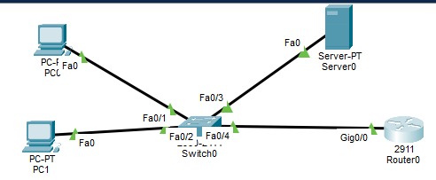
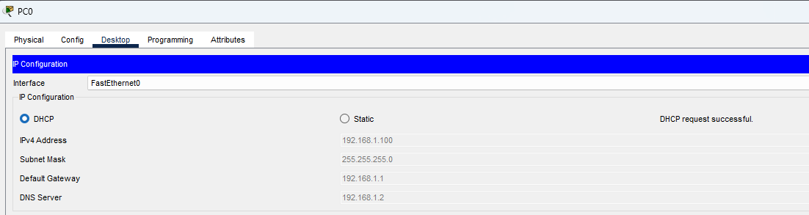

Working of DNS and DHCP in a Network
1. DHCP (Dynamic Host Configuration Protocol)
- DHCP automatically assigns IP addresses to devices when they connect to the network.
- It provides IP address, subnet mask, default gateway and DNS server address.
- It reduces manual configuration and prevents IP address conflicts.
2. DNS (Domain Name System)
- DNS converts hostnames into IP addresses.
- It allows employees to access internal servers using names instead of remembering IP addresses.
- For example, applicationserver.local is translated into the server's IP address.
3. How DNS and DHCP Work Together
- When an employee connects to the network, DHCP automatically assigns an IP address.
- DHCP also provides the DNS server address to the employee's device.
- When the employee enters a server name, DNS translates that name into its corresponding IP address.
- The device then connects to the application server.
4. Identify the Misconfigured Service
There are two problems in the given scenario:
- If employees can access the server by IP address but not by name, DNS may be misconfigured.
- If devices fail to obtain a valid IP address, DHCP may be misconfigured.
Therefore, both DNS and DHCP should be checked.

5. Troubleshooting Steps
- Check whether devices receive valid IP addresses.
- Verify DHCP settings and the available IP address pool.
- Check whether DHCP provides the correct DNS server address.
- Verify the application server's DNS record.
- Test name resolution using nslookup applicationserver.local.
- Test connectivity using the server's IP address and hostname.
Conclusion:
DHCP automatically assigns IP addresses and network settings, while DNS translates hostnames into IP addresses. Both services are important for proper network communication. Correct configuration of both services allows employees to access internal systems easily.

SCENARIO 6: After the IT team installs a new firewall at Nexus Innovations, employees can access the internet but are unable to reach the critical internal application server.
Question: Describe the troubleshooting steps you would take to determine whether the firewall rules are blocking legitimate traffic, and how you would resolve the issue.

ANSWER:

Troubleshooting Firewall Rules Blocking Internal Server Access
If employees can access the internet but cannot reach the internal application server after installing a new firewall, the firewall rules may be blocking legitimate internal traffic.

1. Check Network Connectivity
- Check whether employees' computers are connected to the network.
- Ping the application server using its IP address.
- Verify the server's IP address and default gateway.

2. Check Firewall Rules
- Open the firewall management interface.
- Review the configured inbound and outbound firewall rules.
- Check whether traffic from the employees' network to the application server is being blocked.
- Look for incorrect deny rules or missing allow rules.

3. Check Required Ports
- Identify which ports the application server uses.
- Check whether the firewall allows the required traffic.
- For example, HTTP uses port 80 and HTTPS uses port 443.

4. Check Firewall Logs
- Review firewall logs to identify blocked connection attempts.
- Check the source IP, destination IP, port number and action taken.
- Use this information to identify the rule causing the problem.

5. Modify Firewall Rules
- Create or modify an allow rule for legitimate traffic.
- Allow only the required source network, destination server and service ports.
- Avoid disabling the entire firewall because it can create security risks.

6. Test the Connection Again
- Try accessing the application server from an employee's computer.
- Test the required application services.
- Confirm that employees can access both the internet and the internal application server.

Conclusion
The problem may be caused by incorrect firewall rules blocking legitimate internal traffic. By checking firewall settings, reviewing logs and allowing the required traffic, Nexus Innovations can restore access to the application server while maintaining network security.

Section B — Practical Application
Task 1: Workstation Assembly
Physically assemble a workstation for the startup office and document the component installation sequence.
- Install CPU, RAM, storage, and other core components into the chassis in the correct sequence.
- Connect all required internal cables (power, data, front panel).
- Document each installation step in order.
- System must pass POST (Power-On Self-Test) after assembly.
ANSWER:

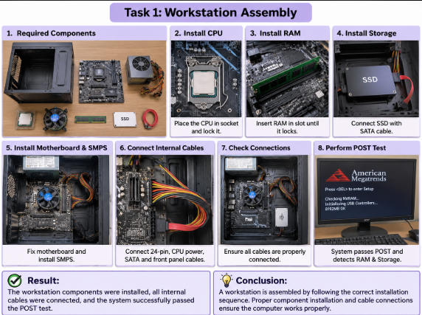

1. Objective:
Physically assemble a workstation for the startup office and document the complete component installation sequence and POST verification.

2. Component Installation Sequence (Step-by-Step Documentation):
- Step 1: Motherboard Component Installation (Outside the Chassis)
  - Place the motherboard on a non-static antistatic surface.
  - Lift the CPU socket lever, align the marker on the processor, gently place the CPU into the socket, and lock the retention arm.
  - Apply thermal paste (if not pre-applied) and mount the CPU cooler/heatsink securely.
  - Insert the RAM modules into the appropriate DIMM slots, pressing down firmly until the side latches click into place.
  - Install the M.2 NVMe SSD into its slot and secure it with the mounting screw.
- Step 2: Chassis (Cabinet) Preparation
  - Remove both side panels of the computer case.
  - Install the Power Supply Unit (PSU) at the designated bay and secure it with screws.
  - Snap the I/O shield (backplate) into the rear cutout of the chassis.
  - Screw in the motherboard standoffs matching the cabinet's form factor.
- Step 3: Motherboard Mounting & Internal Cabling
  - Carefully place the prepared motherboard inside the chassis, aligning it with the rear I/O shield, and fasten it with mounting screws.
  - Power Connections: Connect the 24-pin main motherboard power cable and the 8-pin CPU power cable from the PSU.
  - Data & Front Panel Connections: Connect SATA data cables (if using drives), and plug in the front panel cables (Power Switch, Reset Switch, Power LED, and USB headers) to the bottom pins of the motherboard according to the manual layout.
- Step 4: Power-On Self-Test (POST) Verification
  - Connect the assembled workstation to a power source, monitor, keyboard, and mouse.
  - Press the power button on the front panel.
  - Verification Result: The system successfully powers on, passes POST (Power-On Self-Test) without any beep error codes, displays the manufacturer logo or BIOS screen, and correctly detects the CPU, RAM, and storage devices.
Task 2: RAM Mismatch Troubleshooting
Troubleshoot and resolve a RAM mismatch error within the BIOS/UEFI settings on a startup office workstation.
- Identify the RAM mismatch error via BIOS/UEFI POST messages.
- Determine the root cause (mismatched speed, timing, or capacity).
- Resolve the mismatch by reconfiguring or reseating the RAM correctly.
- Confirm the system boots normally after the fix.

ANSWER:

RAM Mismatch Troubleshooting
Aim: To identify and resolve a RAM mismatch error in a workstation using BIOS/UEFI settings.
Requirements:
- Computer workstation
- Compatible RAM modules
- Motherboard
- Monitor and keyboard

Procedure:
Step 1: Identify RAM Mismatch Error
- Switch on the computer.
- Check the BIOS/UEFI POST messages.
- Look for RAM mismatch or memory-related error messages.
- Check whether the system detects the installed RAM correctly.
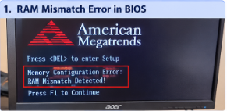
Step 2: Determine the Root Cause
- Check the RAM speed and frequency.
- Verify RAM timing compatibility.
- Check the RAM capacity and motherboard compatibility.
- Identify whether the installed RAM modules have different specifications.
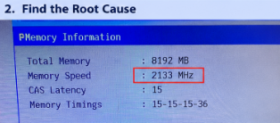
Step 3: Resolve the RAM Mismatch
- Switch off the computer and disconnect the power supply.
- Carefully remove the RAM modules.
- Check the motherboard manual for supported RAM specifications.
- Install compatible RAM modules in the correct slots.
- If required, configure the correct memory settings in BIOS/UEFI.
- Save the settings and restart the computer.
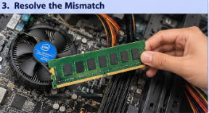
Step 4: Confirm the System Boots Normally
- Restart the computer.
- Enter BIOS/UEFI and check the detected RAM capacity.
- Verify that no RAM mismatch error appears.
- Check whether the operating system starts normally.
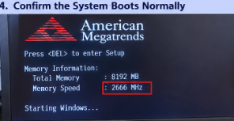

Result:
The RAM mismatch issue was identified and resolved by checking RAM compatibility and correcting the installation or BIOS/UEFI settings.

Conclusion:
RAM compatibility is important for proper computer performance. Correct RAM speed, timing, capacity and installation help prevent memory errors and ensure normal system booting.
Task 3: LAN Topology Build
Build a LAN topology in Packet Tracer for 5 systems and 1 printer using a Class C subnet.
- Use Cisco Packet Tracer to build the topology.
- Include 5 end-systems and 1 network printer.
- Assign IP addresses from a Class C subnet to all devices.
- All assigned IPs must be reachable via Ping.
ANSWER :

LAN Topology Build
Aim: To build a LAN topology for five computers and one network printer using a Class C subnet in Cisco Packet Tracer.
Requirements:
- Cisco Packet Tracer
- One 2960 Switch
- Five PCs
- One Network Printer
- Copper Straight-Through cables

Procedure
Step 1: Create the Topology
- Open Cisco Packet Tracer.
- Add one 2960 switch, five PCs and one network printer.
- Connect all devices to the switch using Copper Straight-Through cables.
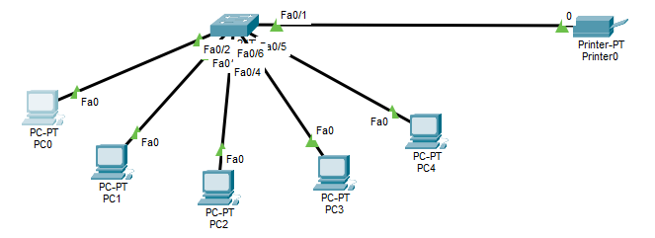
Step 2: Assign IP Addresses
Use the Class C network 192.168.1.0/24.
Device | IP Address | Subnet Mask
PC0 | 192.168.1.1 | 255.255.255.0
PC1 | 192.168.1.2 | 255.255.255.0
PC2 | 192.168.1.3 | 255.255.255.0
PC3 | 192.168.1.4 | 255.255.255.0
PC4 | 192.168.1.5 | 255.255.255.0
Printer0 | 192.168.1.6 | 255.255.255.0
Step 3: Configure the Devices
- Open each PC.
- Go to Desktop → IP Configuration.
- Select Static.
- Enter the assigned IP address and subnet mask.
- Configure the printer through Config → FastEthernet0.
- Enter its IP address and subnet mask.
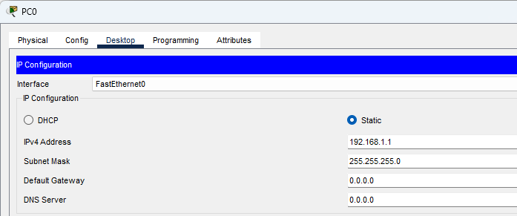
Step 4: Test Connectivity Using Ping
Open PC0 → Desktop → Command Prompt.
Run these commands:
ping 192.168.1.2
ping 192.168.1.3
ping 192.168.1.4
ping 192.168.1.5
ping 192.168.1.6
- Check whether each device responds.
- A successful ping displays Reply from.
- Verify that packet loss is 0%.
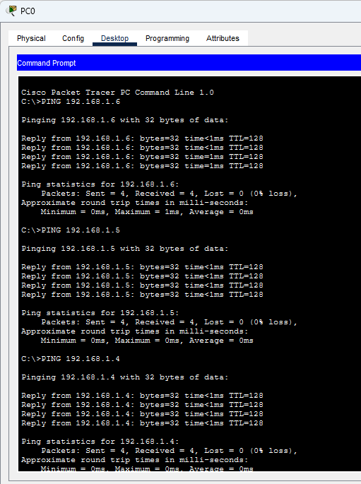

Result
A LAN topology was created using one switch, five computers and one network printer. All devices were assigned unique Class C IP addresses. The printer connectivity test was successful, with 4 packets received and 0% packet loss.

Conclusion
A LAN was successfully configured using a Class C subnet in Cisco Packet Tracer. IP addresses were assigned to all devices and connectivity was tested using the ping command.
Task 4: Clean OS Installation
Perform a clean OS installation with manual disk partitioning and startup optimization on a startup office workstation
- Perform a clean install of Windows/Linux from ISO.
- Manually partition the disk (not guided/automatic partitioning).
- Optimize startup programs/services for faster boot.
- OS must boot without errors after installation.
ANSWER :
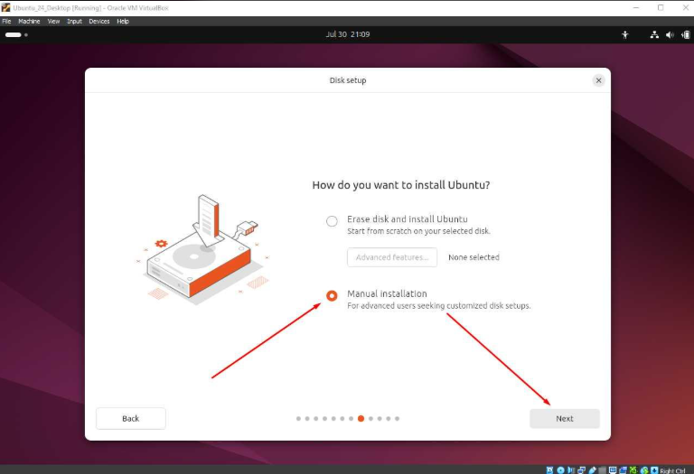
Aim: To perform a clean installation of Ubuntu Linux using an ISO file, manually partition the disk and optimize startup programs for faster booting.

Requirements
- Computer or VirtualBox
- Ubuntu Linux ISO file
- Sufficient disk space
- Minimum system requirements

Procedure
Step 1: Prepare the Installation Media
- Download the Ubuntu ISO file.
- Open VirtualBox and create a new virtual machine.
- Attach the Ubuntu ISO file.
- Start the virtual machine.
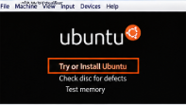
Step 2: Start OS Installation
- Select Try or Install Ubuntu.
- Choose language and keyboard layout.
- Click Install Ubuntu.
- Select the normal installation option.
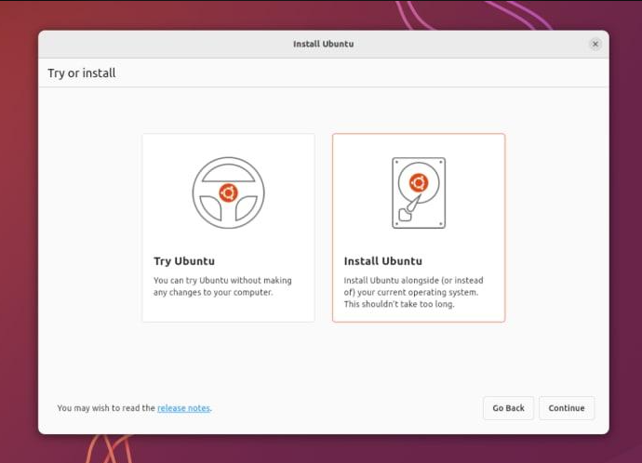
Step 3: Manual Disk Partitioning
- Select the manual partitioning option (Something Else, if available).
- Create the required partitions:
  - Root (/) – for operating system files.
  - Home (/home) – for user files.
  - Swap – for swap space, if required.
- Check the partition sizes and settings.
- Confirm the changes before installation.
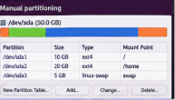
Step 4: Complete Installation
- Select the time zone.
- Enter username and password.
- Start the installation process.
- Wait until installation is complete.
- Restart the virtual machine.

Step 5: Optimize Startup Programs
- Open Ubuntu Settings.
- Check startup applications and services.
- Disable unnecessary startup applications.
- Keep essential system and security services enabled.
- Restart the system to check boot performance.
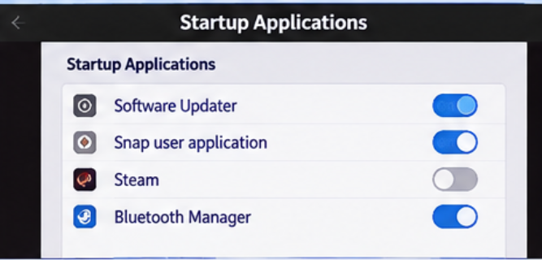

Step 6: Verify OS Boot
- Start the operating system again.
- Check that Ubuntu loads without errors.
- Verify that the partitions are detected correctly.
- Check that the system works properly.


Result
Ubuntu Linux was installed using an ISO file. Manual disk partitioning was performed, unnecessary startup applications were disabled and the system boot was checked.

Conclusion
Clean OS installation provides a fresh and stable operating environment. Manual partitioning organizes storage, while startup optimization helps improve boot performance.

Section C — Mini Capstone Project
Mini Project: Nexus Innovations — Diagnosing Random System Reboots
Objective: At Nexus Innovations, three rendering workstations pass POST every morning but restart randomly during heavy afternoon workloads. The computers are kept inside poorly ventilated desk cabinets. Analyze the probable hardware and thermal causes and propose a remediation plan, combining hardware, power, and troubleshooting concepts from this module.
Your project must:
- Identify the three hardware components most likely to cause random reboots under load.
ANSWER :
The three hardware components most likely to cause random system reboots under heavy workloads are:
1. CPU (Central Processing Unit):
- During heavy workloads, the CPU temperature increases.
- If the CPU overheats due to poor cooling, the computer may restart unexpectedly.
2. Power Supply Unit (PSU):
- The PSU supplies power to all computer components.
- A faulty or insufficient PSU may fail to provide stable power during heavy workloads, causing random restarts.
3. RAM (Random Access Memory):
- Faulty or incompatible RAM can cause system instability.
- It may result in system crashes, errors and unexpected restarts.
Conclusion: CPU overheating, PSU problems and faulty RAM are three possible hardware causes of random system reboots under heavy workloads.
- Explain why the systems pass POST in the morning but fail in the afternoon.
ANSWER :
The workstations pass POST in the morning because their components are relatively cool and the systems are not under heavy workloads.
However, in the afternoon, the computers perform heavy rendering tasks, which increase CPU and GPU temperatures.
The main reasons are:
- Overheating: Heavy workloads increase CPU and GPU temperatures.
- Poor Ventilation: Poorly ventilated desk cabinets trap hot air inside the system.
- Power Consumption: Heavy workloads increase power demand, which may affect an insufficient or faulty PSU.
- Thermal Protection: If components become too hot, the system may shut down or restart automatically to prevent damage.
Conclusion: The systems pass POST in the morning because they are relatively cool. In the afternoon, heavy workloads and poor ventilation may cause overheating and unstable power, resulting in random system restarts.
- Describe how you would use a stress-test tool to confirm a thermal or power issue.
ANSWER :
A stress-test tool is used to check computer stability under heavy workloads. Tools like OCCT and HWMonitor help identify overheating and power-related problems.
Procedure:
- Install the Tools: Install OCCT for stress testing and HWMonitor for monitoring temperatures.
- Check Normal Temperature: Open HWMonitor and note the CPU and GPU temperatures during normal operation.
- Run Stress Test: Open OCCT and run a controlled CPU or GPU stress test.
- Monitor Temperature: Observe whether CPU or GPU temperatures increase abnormally during testing.
- Check System Stability: Check whether the computer restarts, shuts down or shows errors during the test.
- Analyze Results: If temperatures become excessive, it may indicate a cooling problem. If the system restarts under load, investigate the PSU and power connections as well.
Conclusion: Stress-testing tools help identify overheating and possible power-related problems by checking system temperatures and stability under heavy workloads. A stress test alone cannot confirm a faulty PSU; further power supply testing may be required.
- Propose three specific steps to remediate the frequent system restarts.
ANSWER :
The following three steps can help resolve frequent system restarts at Nexus Innovations:
1. Improve Cooling and Ventilation
- Clean dust from CPU fans and cabinet vents.
- Check whether the CPU cooler is working properly.
- Improve airflow by keeping cabinets in a well-ventilated area.
- This helps prevent overheating.
2. Check and Replace the Power Supply (PSU)
- Inspect PSU cables and power connections.
- Test whether the PSU provides stable and sufficient power.
- Replace the PSU if it is faulty or insufficient for the system.
3. Test and Check RAM
- Run Windows Memory Diagnostic or another memory testing tool.
- Check RAM compatibility and proper installation.
- Replace faulty RAM modules if errors are detected.
Conclusion: Improving cooling, checking the power supply and testing RAM can help prevent frequent system restarts and improve workstation stability.
- Provide a brief technical justification for why a PSU upgrade might (or might not) be necessary.
ANSWER :
A PSU upgrade may be necessary if the existing power supply cannot provide enough stable power to the CPU, GPU, and other components during heavy workloads. A faulty or underpowered PSU can cause voltage instability and unexpected system restarts.
Before upgrading, we should check the PSU's wattage, condition, power requirements, and stability under load.
If testing shows that the PSU is working properly and the main problem is overheating due to poor ventilation, upgrading the PSU may not solve the issue.
Conclusion: A PSU upgrade is recommended only if testing confirms that the existing PSU is faulty or insufficient for the system's power requirements.

Section D — AI-Augmented Learning
STEP 1 · BUILD WITH AI
Use an AI tool of your choice (ChatGPT, Claude, GitHub Copilot, etc.) to generate an IP addressing and subnetting plan for Nexus Innovations' startup office network, covering 5 systems and 1 printer.
- The AI-generated plan must specify the subnet, subnet mask, usable host range, and broadcast address.
- The plan must allocate addresses for all 5 systems and 1 printer named in the scenario.
- Instruct the AI to also identify which addresses to reserve for future expansion.
- Document the exact prompt(s) used.
STEP 2 · TEST & DEBUG (WITHOUT AI)
Then, working without AI, verify the plan for errors — overlapping ranges, incorrect network/broadcast addresses, insufficient host capacity, or unreserved growth space — and correct them yourself.

SUBMIT All 3 items required
1. The exact prompt(s) you gave the AI tool.
ANSWER:
"Generate an IP addressing and subnetting plan for Nexus Innovations' startup office network supporting 5 end-systems and 1 network printer. Please specify the network subnet, subnet mask, usable host range, broadcast address, allocate specific IP addresses for all 5 systems and 1 printer, and reserve extra addresses for future office expansion."
2. The AI's original subnetting plan and your corrected version.
ANSWER:
AI's Original Subnetting Plan
Detail | Original plan
Network address | 192.168.10.0
Subnet mask | 255.255.255.248
CIDR | /29
Usable host range | 192.168.10.1 – 192.168.10.6
Broadcast address | 192.168.10.7
Problem: The original plan provides only 6 usable IP addresses. It has no additional address for the router gateway or future expansion.

Corrected Subnetting Plan
I changed the subnet from /29 to /28.
Device | IP address
Router | 192.168.10.1
System 1 | 192.168.10.2
System 2 | 192.168.10.3
System 3 | 192.168.10.4
System 4 | 192.168.10.5
System 5 | 192.168.10.6
Printer | 192.168.10.7
Corrected Network Details
Detail | Corrected plan
Network address | 192.168.10.0
Subnet mask | 255.255.255.240
CIDR | /28
Usable host range | 192.168.10.1 – 192.168.10.14
Broadcast address | 192.168.10.15
Future expansion | 192.168.10.8 – 192.168.10.14 (unused IPs)

3. A 3–4 line note explaining what you changed and why the AI's version needed it.

ANSWER:

What I Changed and Why
I changed the subnet from /29 to /28 because the original plan did not provide enough space for the router and future expansion. The /28 subnet provides 14 usable IP addresses. I assigned separate IP addresses to all five systems, the printer, and the router. The remaining IP addresses are available for future devices.

